Puppet rules
The goal of this exercise is for you to see what Puppet looks like in action. During this lab, you'll be connecting to two different VMs. The VM named puppet is the Puppet Master that has the Puppet rules that you'll need to edit. The VM named linux-instance is a client VM that you'll use to test that your catalog was applied successfully.
The manifests used for the production environment are located in the directory /etc/puppet/code/environments/production/manifests, which contains a site.pp file with the node definitions that will be used for this deployment. On top of that, the modules directory contains a bunch of modules that are already in use. You'll be extending the code of this deployment to add more functionality to it.

Install packages
There's a module named packages on the Puppet VM instance that takes care of installing the packages that are needed on the machines in the fleet. Use the command to visit the module:
cd /etc/puppet/code/environments/production/modules/packages
This module already has a resource entry specifying that python-requests is installed on all machines. You can see the init.pp file using the cat command on the Puppet VM instance.
cat manifests/init.pp
Output:
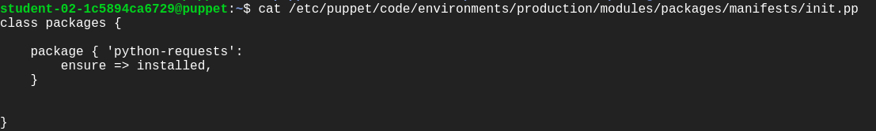
Now, add an additional resource in the same init.pp file within the path /etc/puppet/code/environments/production/modules/packages, ensuring the golang package gets installed on all machines that belong to the Debian family of operating systems (which includes Debian, Ubuntu, LinuxMint, and a bunch of others).
This resource will be very similar to the previous python-requests one. Add edit permission to the file before moving forward using:
sudo chmod 646 manifests/init.pp
To install the package on Debian systems only, you'll need to use the os family fact, like this:
if $facts[os][family] == "Debian" {
# Resource entry to install golang package
}
Now, open the file using nano editor and add the resource entry specifying golang package to be installed on all machines of Debian family after the previous resource entry.
The snippet would now look like this:
if $facts[os][family] == "Debian" {
package { 'golang':
ensure => installed,
}
}
The complete init.pp file would now look similar to the below file:
class packages {
package { 'python-requests':
ensure => installed,
}
if $facts[os][family] == "Debian" {
package { 'golang':
ensure => installed,
}
}
}
After this, we will also need to ensure that the nodejs package is installed on machines that belong to the RedHat family. Refer to the below snippet for this.
if $facts[os][family] == "RedHat" {
#Resource entry
}
Complete the above snippet just like the previous one.
The complete init.pp file should now look like this:
class packages {
package { 'python-requests':
ensure => installed,
}
if $facts[os][family] == "Debian" {
package { 'golang':
ensure => installed,
}
}
if $facts[os][family] == "RedHat" {
package { 'nodejs':
ensure => installed,
}
}
}
Once you've edited the file and added the necessary resources, you'll want to check that the rules work successfully. We can do this by connecting to another machine in the network and verifying that the right packages are installed.
We will be connecting to linux-instance using its external IP address. To fetch the external IP address of linux-instance, use the following command:
gcloud compute instances describe linux-instance --zone=us-central1-a --format='get(networkInterfaces[0].accessConfigs[0].natIP)'
This command outputs the external IP address of linux-instance. Copy the linux-instance external IP address, open another terminal and connect to it. Follow the instructions given in the section Accessing the virtual machine by clicking on Accessing the virtual machine from the navigation pane at the right side.
Now manually run the Puppet client on your linux-instance VM instance terminal:
sudo puppet agent -v --test
This command should run successfully and the catalog should be applied.
Output:
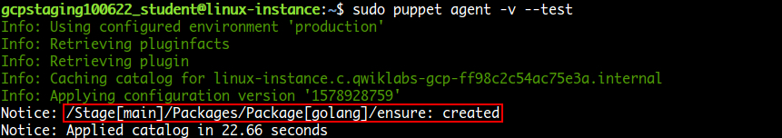
Now verify whether the golang package was installed on this instance. This being an machine of the Debian family should have golang installed. Use the following command to verify this:
apt policy golang
Output:
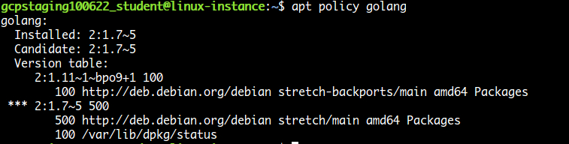
With this, you've seen how you can use Puppet's facts and package resources to install specific packages on machines within your fleet.
Click Check my progress to verify the objective.

Fetch machine information
It's now time to navigate to the machine_info module in our Puppet environment. In the Puppet VM terminal, navigate to the module using the following command:
cd /etc/puppet/code/environments/production/modules/machine_info
The machine_info module gathers some information from the machine using Puppet facts and then stores it in a file. Currently, the module is always storing this information in /tmp/machine_info.
Let's check this out:
cat manifests/init.pp
Output:
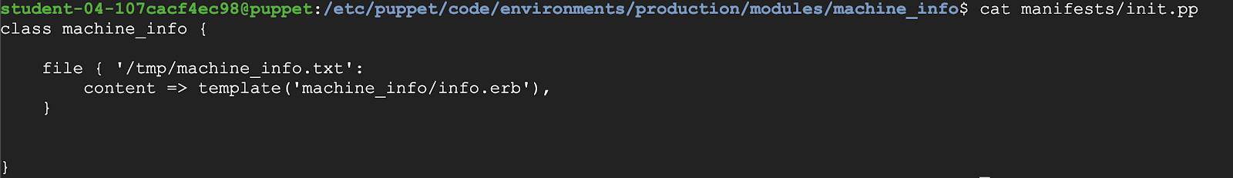
You can view the path in the above file. This path doesn't work for Windows machines. So, you need to adapt this rule for Windows.
Add edit permission to the file using the following command before we adapt the rule.
sudo chmod 646 manifests/init.pp
Now we will be using $facts[kernel] fact to check if the kernel is "windows". If so, set a $info_path variable to "C:\Windows\Temp\Machine_Info.txt", otherwise set it to "/tmp/machine_info.txt". To do this, open the file using nano editor and add the below rule after the default path within the class machine_info.
if $facts[kernel] == "windows" {
$info_path = "C:\Windows\Temp\Machine_Info.txt"
} else {
$info_path = "/tmp/machine_info.txt"
}
The file should now look similar to:
class machine_info {
file { '/tmp/machine_info.txt':
content => template('machine_info/info.erb'),
}
if $facts[kernel] == "windows" {
$info_path = "C:\Windows\Temp\Machine_Info.txt"
} else {
$info_path = "/tmp/machine_info.txt"
}
}
By default the file resources are stored in the path defined in the name of the resource (the string in the first line) within the class. We can also set different paths, by setting the path attribute.
We will now be renaming the resource to "machine_info" and then use the variable in the path attribute. The variable we are using to store the path in the above rule is $info_path.
Remove the following part from the file manifests/init.pp.
file { '/tmp/machine_info.txt':
content => template('machine_info/info.erb'),
}
And add the following resource after the rule within the class definition:
file { 'machine_info':
path => $info_path,
content => template('machine_info/info.erb'),
}
The complete manifests/init.pp file should now look like this:
class machine_info {
if $facts[kernel] == "windows" {
$info_path = "C:\Windows\Temp\Machine_Info.txt"
} else {
$info_path = "/tmp/machine_info.txt"
}
file { 'machine_info':
path => $info_path,
content => template('machine_info/info.erb'),
}
}

Puppet Templates
Templates are documents that combine code, data, and literal text to produce a final rendered output. The goal of a template is to manage a complicated piece of text with simple inputs.
In Puppet, you'll usually use templates to manage the content of configuration files (via the content attribute of the file resource type).
Templates are written in a templating language, which is specialized for generating text from data. Puppet supports two templating languages:
- Embedded Puppet (EPP) uses Puppet expressions in special tags. It's easy for any Puppet user to read, but only works with newer Puppet versions. (≥ 4.0, or late 3.x versions with future parser enabled.)
- Embedded Ruby (ERB) uses Ruby code in tags. You need to know a small bit of Ruby to read it, but it works with all Puppet versions.
Now, take a look at the template file using the following command.
cat templates/info.erb
Puppet templates generally use data taken from Puppet variables. Templates are files that are pre-processed, some values gets replaced with variables. In this case, the file currently includes the values of three facts. We will be adding a new fact in this file now.
Add edit permissions to the file using templates/info.erb using the following command:
sudo chmod 646 templates/info.erb
Now open the file using nano editor and add the following fact just after the last fact within the file:
Network Interfaces: <%= @interfaces %>
The template should now look like this:
Machine Information
-------------------
Disks: <%= @disks %>
Memory: <%= @memory %>
Processors: <%= @processors %>
Network Interfaces: <%= @interfaces %>
}
To check if this worked correctly, return to linux-instance VM terminal and manually run the client on that machine using the following command:
sudo puppet agent -v --test
This command should run successfully and the catalog should be applied.
Now verify that the machine_info file has the required information using:
cat /tmp/machine_info.txt
Output:
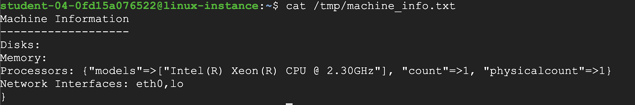
And with that, you've seen how you can fetch machine information and store it according to the operating system.
Click Check my progress to verify the objective.

